Competitive Shooters of Lake Norman USPSA March 26th, 2026
COURSE DESIGNER: Ike Starnes
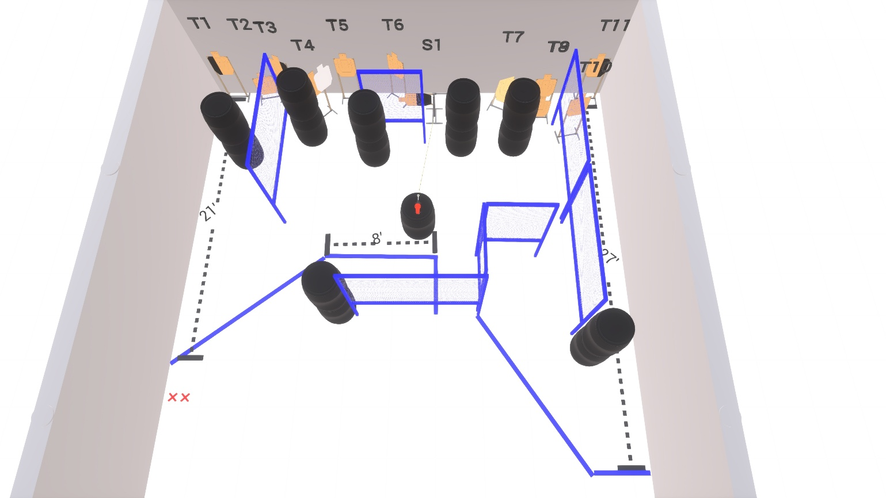

Stage 2 – I wish we had a Holy Monkey
24 rounds, 120 points, Comstock
There are 12 cardboard targets with some no-shoots.
Starting with both feet on the Xs.
Handgun is loaded and holstered, wrists below belt.
PCC is loaded held in both hands, stock touching belt.
On the audible start signal, engage targets from within the shooting area.

